Was it murder?
Using medicine in TV murder mysteries for subject-specific language learners
Tatort Wien „Grenzfall“, 2015, ORF (Österreichischer Rundfunk)
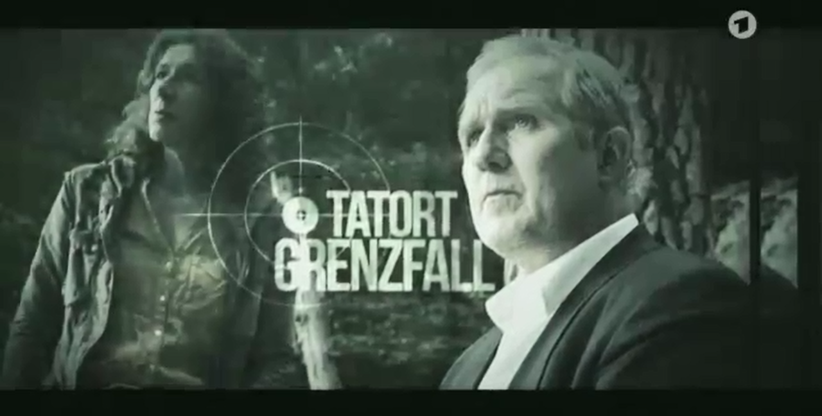

https://www.youtube.com/watch?v=Ed2zWaJ-E84:
27:06 - 29:04
30:38 - 31.39
33:00 - 34:36
35:14 - 36:43

Students on their year abroad increasingly continue to watch their favourite series in English via streaming platforms and they are missing out on listening comprehension and on cultural observations. Hopefully, with this activity or similar ones, students abroad and in the UK will begin to enjoy watching foreign films.
Crime fiction is a very popular genre, both in fictional writing, in adaptations of books for cinema which are set in various cities.
On television, there are numerous Krimis on German and Austrian television, many with specific regionalisms with regards to language or culture, for example the various “SOKO” series (SOKO = short for Sonderkommission), but most importantly also the “Tatort” (= crime scene) series that celebrated its 40th anniversary in 2010 and is also filmed on various locations in Germany, Austria and a little bit in Switzerland.
From a language learning and teaching perspective, these provide students with numerous technical terms and medical expressions, as well as dialects and sociolects, but also registers between police, lawyers and suspects or relatives of victims from various backgrounds.
Rather grim vocabulary comes from the sheer variety of natural and unnatural deaths that can occur, with anything from strangulation, knifing, stabbing, shooting, suffocating… The list goes on.
Another aspect from a linguistic point of view are the ways of addressing people and using appropriate titles, which could be academic titles, police ranks, but also – in German, or in fact in many languages other than English – the polite form of address “Sie” and the informal form of address “du”.

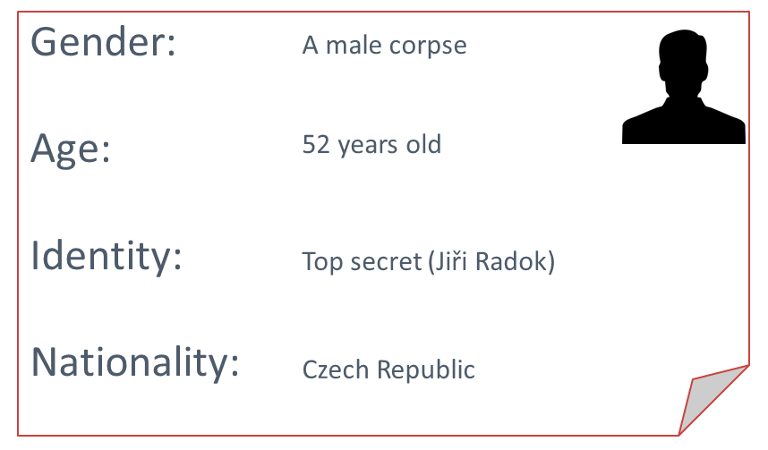
Victim profile:

Vocabulary for death by drowning | Vocabulary for diabetes
Typical symptoms of drowning:  The victim is fighting against drowning on the water’s surface. Water can be found in the lungs and in the respiratory system.  Fine white froth at the mouth and nose caused by rapid breathing of both water and air  Atypical symptoms of drowning:  No water in the lungs because the victim was drowsy or unconscious due to alcohol or drugs  (or pulled into the water by a river monster) | hypoglycaemic shock or coma  glucose doses  insulin kit  needle  insulin pen  puncture  to inject insulin  syringe  a subcutaneous / intramuscular injection in the thigh
Conclusion
It is atypical because the froth is missing from the mouth | The results from the lab have shown extremely high doses of insulin in the body, even though his stomach was empty. As an experienced diabetic, he carried glucose in his pocket that was untouched. Why didn’t he take it?
Cultural observations:

Forms of address
Compared with British universities, the forms of address by the professor are rather formal, using colleague, dear comrades in forensics, ladies and gentlemen etc.

Students‘ behaviour during the lecture
Student attendance is low, they eat and drink, play on their phones, chew pencils, don’t concentrate, but they add their opinion to that case.

The tone of voice between the Detective and the pathologist
Humorous, but also tetchy, informal.

Film activities on which to build:
Psychoanalysis “Wilsberg – Kein Weg zurück” https://www.youtube.com/watch?v=bh4tU_uGzNQ

CBBC “Operation Ouch”:
For teaching English as a foreign language or summarizing videos into the target language, the series „Operation Ouch“ from CBBC that’s done by medical doctors Chris and Xand Van Tuileken, is very well done and even if its target group are children, it is done in a humorous way that’s also interesting for adults.

